Latest Round-ups:
Season 2019/20
#22
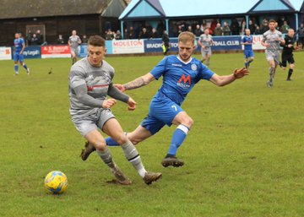
Boxing Day Action: Tavistock became the first side since late August to defeat Plymouth Parkway in the Premier Division after completing an impressive 3-2 victory at Bolitho Park. The away side made an electric start to the contest, and having gone ahead in the second minute through Dan Evans, they then doubled their advantage thanks to a Liam Prynn goal. Parkway halved the deficit towards the end of the first half through Teigan Rosenquest, but it was Tavistock who score d the all-important fourth goal when Jordan Annear struck against his former team. The hosts pulled another goal back midway through the second half thanks to Mikey Williams, but they were unable to find an equaliser, handing Tavistock a Christmas bonus. In the other Devon derby, Exmouth Town scored four first half goals on their way to a 4-2 defeat of Buckland Athletic. It was all one-way traffic during the opening 45 minutes, and after Tom Gardner had headed Town ahead in the early stages, Jordan Harris then struck a double, with Max Gillard also finding the back of the net to make it 4-0 at the interval. To their credit, Buckland enjoyed the better of the second half, and made the result slightly more respectable thanks to goals from Will Hancox and Richard Groves. There was late drama in Wiltshire, where Bradford edged past Westbury by two goals to one to extend their lead at the top of the division. The Bobcats had been headed towards a 1-0 victory for much of the game, after Charlie Maddison capitalised on a keeper error to prod his side into an early lead. Westbury battled on however, and managed to grab an equaliser in the closing stages, with Jason Henley scoring from the penalty spot. Bradford were able to hit back however, and a smashed finish five minutes from time by Jamie Lyons led them to all three points. The performance of the day belonged to Sacha Tong, with the Hallen forward nabbing a hat-trick during his side’s 4-2 victory away at Cribbs. After teammate Matt Davis had broken the deadlock in the tenth minute, Tong then scored either side of the interval to help Hallen compile a comfortable three-goal advantage. Ethan Feltham struck twice in the final quarter-hour to threaten a fightback for Cribbs, but Tong extinguished their ability to do so, when he completed his treble in the closing stages.
Action from the Wiltshire derby between Bradford and Westbury, courtesy of Martin Pearce.
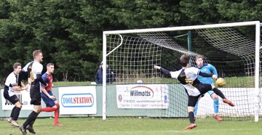
Roman Glass St George gained revenge over Clevedon Town, defeating their visitors 2-0 to flip the script from their defeat to the same opponent 12 days previously. All the scoring was done in the early stages at Oaklands Park, with two goals in the opening seven minutes from George Lloyd and Lewis Wentland proving to be enough for the Glass. Another side to run out victors on their home patch was Shepton Mallet, with four different goalscorers helping them ease past the struggling Odd Down 4-0. Many of the usual suspects got on the scoresheet for Mallet, with Aaron Seviour putting them ahead, before Conrad Peck, Asa White and Daryl Charman joined him in finding the back of the net. In Thursday’s only 3pm kickoff, Street stormed to a 4-2 victory away at Bridgwater to hand their local rivals a rare defeat at their Fairfax Park home. The visitors made a dream start, finding themselves one goal to the good inside the opening ten minutes thanks to a thumping volley from Callum Thompson. Bridgwater started to push forward as the first half went on, and managed to level the scores seven minutes before the interval thanks to a long-range free kick from Ross McErlain. Street regrouped at half-time, and came out firing in the second half, with skipper Cameron Andrews putting them back ahead, before Leighton Thomas extended the lead to 3-1. A goal from Steve Murray threatened to derail Street’s charge, but they weren’t to denied, and a late lobbed finish from Kyle Strange wrapped up their deserved 4-2 victory. In another derby, the spoils were shared at the WDS Stadium where Bitton relied on a late equaliser to grab a 2-2 draw with Cadbury Heath. A George Boon cross to the back post found Matt Huxley who fired the Heath ahead, only for Bitton to respond, levelling up six minutes later. The away side then moved into the lead once more when a deflected long range effort from Kristian Lee found the back of the net, but with less than five minutes remaining, Bitton grabbed a late equaliser to deny the Heath from taking home all three points.
Shepton Mallet on the attack during their 4-0 win over Odd Down, courtesy of Haydn Jones.
In Boxing Day’s First Division fixtures, all four home team’s prevailed, with Wells moving up to fourth thanks to a 1-0 win over Bishop Sutton. Leading scorer Harry Foster proved to be the difference for Wells once again, with his 24th minute effort leading them to their third league win on the bounce. After over 50 days without a home league fixture, Calne Town returned to Bremhill View with a bang, with Jamal Chevolleau scoring in either half of their 3-0 victory over Devizes.

At Bowdens Park, Cheddar ended a run of three matches without a victory by defeating Bishops Lydeard by four goals to two. The Cheesemen took no time at all in forging ahead, with Chris Coombs making no mistake after being afforded an early one-on-one opportunity. In a repeat of the first half, Cheddar bounded out of the dressing rooms, and doubled their advantage two minutes after the break thanks to a volleyed finish from Adam Jones. The strike duo were at it again for the home side midway through the second half with Jones setting up Coombs to make it 3-0, before Lydeard pulled a goal back from the spot through Luke Bryant. Jones then joined Coombs in scoring his second of the afternoon to restore Cheddar’s three-goal advantage, with Jake Quick adding a stoppage time consolation for the visitors. Bristol Telephones registered just their second league win of the campaign at Stockwood Lane, beating Hengrove Athletic 3-0. Dhani Golding returned to scoring form for the home side, beating the visiting keeper twice, with George White also grabbing a goal for the victorious Phones.
Weekend Action: Bradford Town suffered a rare defeat in the Premier Division on Saturday afternoon, relinquishing a first-half lead at the hands of Keynsham. Lewis Powell slid the ball home for the league leaders during the opening 25 minutes, with Keynsham getting level before the break to set up an enticing second-half. The K’s completed their comeback soon after the interval when Craig Wilson fired them ahead, but Bradford then had the opportunity to hit back when they were awarded a spot kick. However, Ash Clark thwarted Tyson Pollard from 12 yards to maintain the host’s lead, which Wilson then added to in the closing stages to complete the 3-1 win. Plymouth Parkway capitalised on the Bobcats slip-up, beating Westbury 2-1 to end the year just three points off the top. A bundled opener from Mikey Williams put the Devon side ahead in the 20th minute, but United managed to restore parity when Joe Stradling beat a couple of defenders before rifling the ball home. The winner came midway through a tight second half, with Mike Landricombe notching a rare goal for Parkway when he reacted fastest to a loose ball in the opposition area. Exmouth Town came out on top in a seven-goal thriller away at Street to extend their winning run to three matches (pictured right, courtesy of John Pool). After storming into a two-goal lead thanks to Jamie Durrant and Jordan Harris, Exmouth looked to have wrapped up victory when Ace High put them three goals to the good early in the second half. Street had other ideas however, and having claimed a big win over Bridgwater two days previously, they used that belief to level the scores during a dramatic second half, with Ollie Hebbard and Leighton Thomas each on the scoresheet. The game’s biggest moment was still to come however, and with stoppage time underway, Harris found enough space in the box to complete his second double of the Christmas period to break Street hearts.
On a good day all round for the Devon team’s, Buckland Athletic romped to a 4-2 win at home to Cribbs. Having fallen behind to Ethan Feltham’s opener, goals from Richard Groves and Lloyd Gardner soon turned the game in Buckland’s favour. Gardner then did well to tee up Groves who extended the hosts advantage, before Exeter loanee Lewis Wilson tucked home a fourth on his full debut. Tavistock made it a full-house of victories for the county, with Jack Crago’s solitary goal on the cusp of half-time handing them a 1-0 win over Brislington. A strong fightback from Clevedon Town helped them defeat Bridgwater 2-1, handing them third position on the league table. The visitors were looking to hit back after suffering defeat on Boxing Day, and they started well, with Jake Llewellyn producing a powerful finish to put them ahead on the 20 minute mark. Clevedon closed out the first half on top, with Elliot Nicholson heading them level, and then midway through the second half, they secured all three points when Syd Camper beat the visiting keeper. Two goals from Jake Moore helped Chipping Sodbury beat Roman Glass St George 2-1, while Bitton added to Odd Down’s woes with a clinical 5-1 victory in Bath.
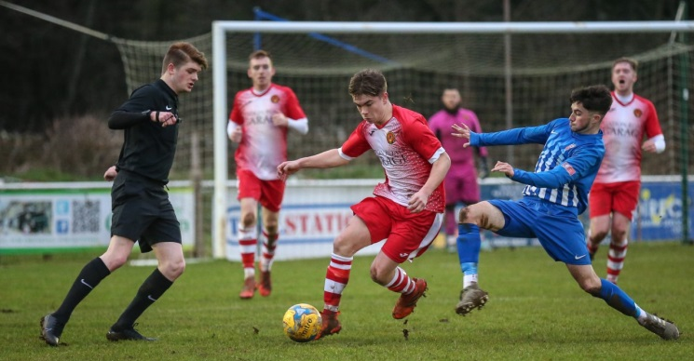
In the First Division, Sherborne Town moved to within one point of the league leaders thanks to a 3-1 victory over Wincanton. With the midway of the point approaching, the Zebras have positioned themselves firmly in the promotion race, after a pair of goals from Sam Farthing, plus a goal from the in-form Alex Murphy leading them to an 11th league win of the season. Corsham Town ended the year on a high, coming from behind to beat Warminster 2-1. After their visitors surged ahead, Corsham got back on level terms during the first half when Alex Hillier headed home an Ash Alchin cross. Then, the most dramatic of endings saw Corsham bag all three points, with Jon Bazley scoring an injury-time winner following a Corey Harbour-Burgess corner. Oldland Abbotonians produced a similar fightback of their own, beating table-toppers Longwell Green Sports 2-1 despite having trailed at the interval. Having not played a league fixture in three weeks, Longwell Green could have been forgiven for being a little bit rusty, but that wasn’t the case at all, and they earned a deserved half-time lead when Luke Bryan fired home. Oldland responded terrifically, and having earlier slide home the leveller, Cash Vinall completed a marvellous double, beating the home keeper from all of 30 yards with a well-stuck free kick five minutes from time. There was also a 2-1 win for Ashton & Backwell United, with goals from Joe Bishop and Billy Devoy proving to be enough to fight off the challenge of Portishead who had levelled affairs at the end of the first half through George Parsons.
Action from Corsham’s win over Warminster, courtesy of John Cuthbertson.

Western League Statistical Leaders

PREMIER DIVISION LEADING GOAL SCORERS (League only):
Adam Carter (Plymouth Parkway) – 22
Jordan Harris (Exmouth Town) – 15
Jack Fillingham (Shepton Mallet) – 13
Lucas Vowles (Clevedon Town) – 13
Leighton Thomas (Street) – 13
Neikell Plummer (Bradford & Brislington) - 12
Gary Higdon (Bradford Town) – 11

PREMIER DIVISION TOP ATTENDANCES:
Plymouth Parkway 2 Tavistock 3, Thursday 26th December 2019 - 564
Bridport 0 Bridgwater Town 6, Sunday 6th October 2019 – 347
Wellington 0 Exmouth Town 2, Sunday 6th October 2019 - 315

FIRST DIVISION LEADING GOAL SCORERS (League only):
James Rustell (Radstock Town) – 17
Harry Foster (Wells City) – 15
Stuart Windsor (Calne Town) – 12
Alex Murphy (Sherborne Town) – 11
Adam Wright (Cheddar) – 10
Danny Carter (Longwell Green Sports) – 10
Toby Cole (Wincanton Town) – 10

FIRST DIVISION TOP ATTENDANCES:
Warminster Town 2 Bristol Telephones 3, Saturday 5th October 2019 - 369
Longwell Green Sports 1 Oldland Abbotonians 2, Saturday 28th December 2019 - 289
Portishead Town 3 Longwell Green Sports 5, Saturday 5th October 2019 – 262

LEADING SCORERS IN ALL COMPETITIONS:
Jack Crago (Tavistock) - 28
James Rustell (Radstock Town) – 22
Adam Carter (Plymouth Parkway) – 22
Harry Foster (Wells City) – 19
Gary Higdon (Bradford Town) – 18
Jack Fillingham (Shepton Mallet) - 18
Tyson Pollard (Bradford Town) - 17

*All goalscoring stats via Full-Time FA website

Boxing Day Results
Thursday 26th December 2019
Premier Division
Bitton 2-2 Cadbury Heath 147
Bradford Town 2-1 Westbury United 252
Bridgwater Town 2-4 Street 237
Cribbs 2-4 Hallen 95
Exmouth Town 4-2 Buckland Athletic 220
Plymouth Parkway 2-3 Tavistock 564
Roman Glass St George 2-0 Clevedon Town 80
Shepton Mallet 4-0 Odd Down 156
First Division
Bristol Telephones 3-0 Hengrove Athletic 63
Calne Town 3-0 Devizes Town 167
Cheddar 4-2 Bishops Lydeard 117
Wells City 1-0 Bishop Sutton 50
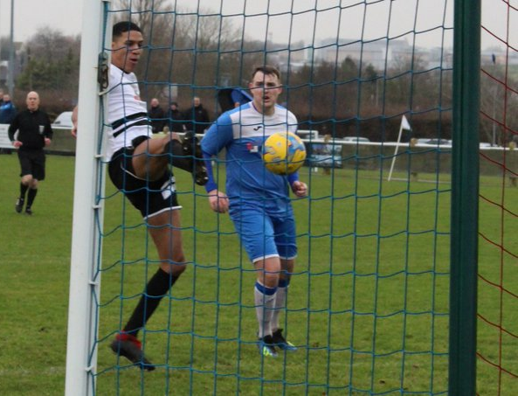

Christmas Treble
Sacha Tong (left) played a starring role on Boxing Day, bagging a hat-trick during Hallen’s 4-2 victory away at Cribbs.

Weekend Results
Saturday 28th December 2019
Premier Division
Buckland Athletic 4-2 Cribbs 150
Chipping Sodbury Town 2-1 Roman Glass St George 161
Clevedon Town 2-1 Bridgwater Town 206
Keynsham Town 3-1 Bradford Town 304
Odd Down 1-5 Bitton 61
Street 3-4 Exmouth Town 125
Tavistock 1-0 Brislington
Westbury United 1-2 Plymouth Parkway 123
First Division
Ashton & Backwell United 2-1 Portishead Town 103
Corsham Town 2-1 Warminster Town 210
Longwell Green Sports 1-2 Oldland Abbotonians 289
Sherborne Town 3-1 Wincanton Town 210
Upcoming Fixtures
Saturday 4th January 2020 (KICK OFF AT 3.00PM UNLESS NOTED)
Premier Division
Bradford Town vs Odd Down
Bridgwater Town vs Bridport
Clevedon Town vs Buckland Athletic
Exmouth Town vs Bitton
Hallen vs Cadbury Heath
Plymouth Parkway vs Brislington
Shepton Mallet vs Chipping Sodbury Town
Street vs Roman Glass St George
Tavistock vs Keynsham Town
Wellington vs Westbury United
First Division
Bishop Sutton vs Oldland Abbotonians
Bishops Lydeard vs Welton Rovers
Devizes Town vs Almondsbury
Hengrove Athletic vs Cheddar
Lebeq United vs Ashton & Backwell United
Longwell Green Sports vs Bristol Telephones
Portishead Town vs Corsham Town
Warminster Town vs Radstock Town
Wells City vs Sherborne Town
Wiltshire FA Senior Cup – Quarter Final
Trowbridge Town vs Calne Town 13:30KO

Les Phillips Cup update
Quarter Finals (to be played Tuesday 18th & Wednesday 19th of February)
Hallen vs Cheddar or Cribbs
Tavistock or Clevedon Town vs Warminster Town
Bridgwater Town vs Shepton Mallet or Exmouth Town
Roman Glass St George vs Bradford Town or Bitton

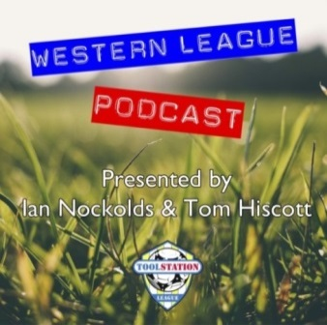
Be sure to check out the latest podcast, where Ian, Tom & guests recap all the latest news and results from around the Western League. To follow along all season, each broadcast will be available at the following link: http://www.toolstationleague.com/podcasts.php

League Tables
Premier Division
 |  | P | W | D | L | F | A | GD | PTS
1 | Bradford Town | 17 | 14 | 1 | 2 | 50 | 18 | 32 | 43
2 | Plymouth Parkway | 16 | 13 | 1 | 2 | 61 | 18 | 43 | 40
3 | Clevedon Town | 21 | 12 | 3 | 6 | 46 | 38 | 8 | 39
4 | Exmouth Town | 15 | 12 | 1 | 2 | 40 | 13 | 27 | 37
5 | Hallen | 19 | 11 | 3 | 5 | 39 | 33 | 6 | 36
6 | Shepton Mallet | 18 | 10 | 3 | 5 | 40 | 26 | 14 | 33
7 | Tavistock | 15 | 10 | 2 | 3 | 43 | 22 | 21 | 32
8 | Bitton | 17 | 10 | 1 | 6 | 47 | 27 | 20 | 31
9 | Bridgwater Town | 18 | 9 | 4 | 5 | 47 | 28 | 19 | 31
10 | Street | 22 | 8 | 3 | 11 | 47 | 51 | -4 | 27
11 | Brislington | 21 | 8 | 3 | 10 | 31 | 51 | -20 | 27
12 | Buckland Athletic | 17 | 8 | 1 | 8 | 31 | 33 | -2 | 25
13 | Westbury United | 20 | 7 | 3 | 10 | 35 | 32 | 3 | 24
14 | Keynsham Town | 19 | 7 | 3 | 9 | 36 | 42 | -6 | 24
15 | Cribbs | 20 | 7 | 2 | 11 | 31 | 48 | -17 | 23
16 | Cadbury Heath | 21 | 5 | 7 | 9 | 29 | 43 | -14 | 22
17 | Roman Glass St George | 17 | 6 | 2 | 9 | 36 | 24 | 12 | 20
18 | Chipping Sodbury Town | 20 | 4 | 1 | 15 | 25 | 63 | -38 | 13
19 | Bridport | 20 | 4 | 1 | 15 | 25 | 67 | -42 | 13
20 | Wellington | 19 | 3 | 2 | 14 | 20 | 51 | -31 | 11
21 | Odd Down | 18 | 3 | 1 | 14 | 16 | 47 | -31 | 10

First Division
 |  | P | W | D | L | F | A | GD | PTS
1 | Longwell Green Sports | 17 | 11 | 2 | 4 | 43 | 24 | 19 | 35
2 | Calne Town | 17 | 11 | 2 | 4 | 29 | 12 | 17 | 35
3 | Sherborne Town | 17 | 11 | 1 | 5 | 40 | 25 | 15 | 34
4 | Radstock Town | 15 | 10 | 1 | 4 | 42 | 23 | 19 | 31
5 | Wells City | 16 | 9 | 4 | 3 | 37 | 20 | 17 | 31
6 | Ashton & Backwell United | 17 | 8 | 5 | 4 | 28 | 31 | -3 | 29
7 | Cheddar | 17 | 8 | 4 | 5 | 33 | 27 | 6 | 28
8 | Wincanton Town | 15 | 8 | 2 | 5 | 30 | 32 | -2 | 26
9 | Oldland Abbotonians | 16 | 7 | 5 | 4 | 21 | 23 | -2 | 26
10 | Corsham Town | 18 | 8 | 2 | 8 | 30 | 42 | -12 | 26
11 | Warminster Town | 17 | 8 | 0 | 9 | 33 | 23 | 10 | 24
12 | Lebeq United | 17 | 8 | 0 | 9 | 37 | 37 | 0 | 24
13 | Bishops Lydeard | 15 | 6 | 2 | 7 | 33 | 28 | 5 | 20
14 | Welton Rovers | 18 | 5 | 4 | 9 | 20 | 33 | -13 | 19
15 | Portishead Town | 16 | 5 | 3 | 8 | 33 | 32 | 1 | 18
16 | Almondsbury | 16 | 5 | 3 | 8 | 23 | 29 | -6 | 18
17 | Hengrove Athletic | 17 | 4 | 4 | 9 | 9 | 37 | -28 | 16
18 | Devizes Town | 16 | 3 | 4 | 9 | 28 | 36 | -8 | 13
19 | Bishop Sutton | 15 | 2 | 2 | 11 | 18 | 31 | -13 | 8
20 | Bristol Telephones | 18 | 2 | 2 | 14 | 24 | 46 | -22 | 8

